**Phase 10: Final Presentation & Demo Day**

This phase is the **culmination of the Expense Report System project**, where the complete solution is presented to stakeholders. The goal is to demonstrate system functionality, explain the technical implementation, collect feedback, and ensure a smooth transition to production.

Name: Shaik Javeed Ahammad

**1. Pitch Presentation**

* Overview of the business problem and solution.
* Slides highlighting **Expense Report lifecycle**, **Automation Flows**, and **Security Review**.
* Benefits such as reduced approval delays, better financial insights, and compliance.

**2. Demo Walkthrough**

* Step 1: Employee submits an expense request.
* Step 2: Manager receives approval request via Salesforce Flow.
* Step 3: Finance team processes reimbursement.
* Step 4: Dashboard updates in real time with expense data.

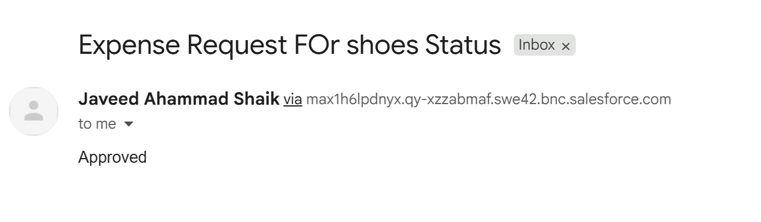

**3. Feedback Collection**

* Collect feedback from **Managers**, **Finance Team**, and **Executives**.
* Use **Google Forms, Salesforce Surveys, or MS Forms** to capture enhancement requests.
* Document common improvement areas for future releases.

**4. Handoff Documentation**

* **Admin Guide**: Org setup, users, profiles, security model.
* **Developer Guide**: Apex classes, triggers, integration notes.
* **User Guide**: Expense submission, approval process, dashboards.

[JAVEED70516/Streamlined-Expense-Approval-System](https://github.com/JAVEED70516/Streamlined-Expense-Approval-System)   
  


**5. Project Showcase**

* Publish project repo and demo video on GitHub.

<https://drive.google.com/file/d/1hZiqWNFDOiefVWENw5BWqHwvo9Qta7sp/view?usp=sharing>